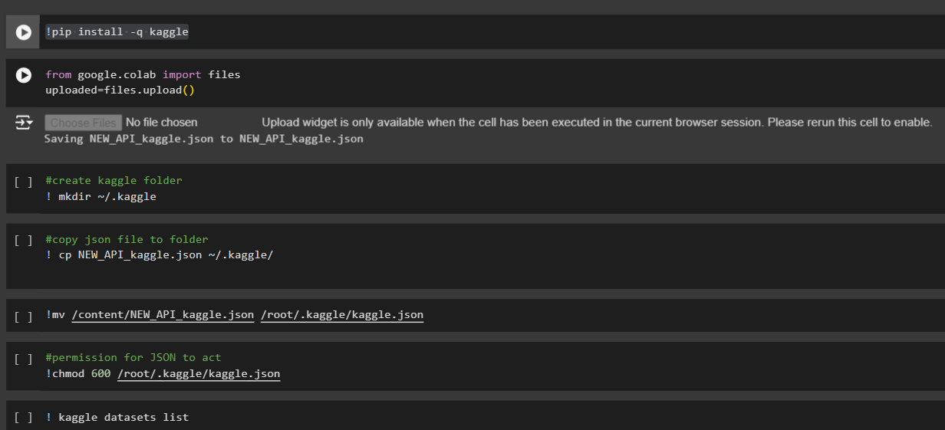

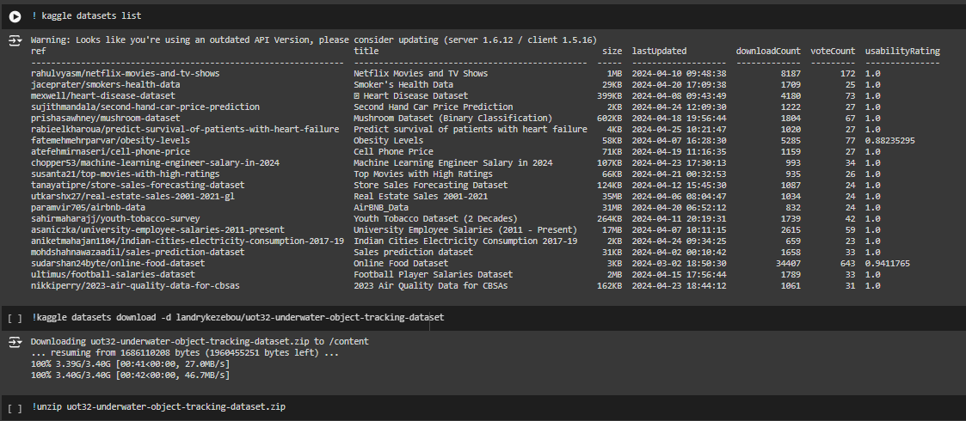

#PSNR (Peak Signal-to-Noise Ratio): Measures the quality of the enhanced image compared to the original image in terms of noise.

#SSIM (Structural Similarity Index): Measures the similarity between the enhanced image and the original image in terms of structural information.

import cv2

import numpy as np

from skimage.metrics import peak_signal_noise_ratio as psnr

from skimage.metrics import structural_similarity as ssim

from google.colab.patches import cv2_imshow

# Read the original image

original_image = cv2.imread('/content/Octopus1/img/10.jpg')

# Check if the original image is None

if original_image is None:

print("Error: Unable to read the original image.")

else:

# Define a function to evaluate image enhancement techniques

def evaluate_performance(enhanced_image):

# Calculate PSNR

psnr_score = psnr(original_image, enhanced_image)

# Calculate SSIM

ssim_score = ssim(original_image, enhanced_image, multichannel=True)

return psnr_score, ssim_score

# Define a function to display images and evaluation scores

def display_results(original_image, enhanced_image, psnr_score, ssim_score):

# Display original and enhanced images

cv2_imshow(original_image)

cv2_imshow(enhanced_image)

# Print evaluation scores

print('PSNR:', psnr_score)

print('SSIM:', ssim_score)

# Read the enhanced image obtained from the specific technique

enhanced_image = cv2.imread('enhanceDsd_image.jpg')

# Check if the enhanced image is None

if enhanced_image is None:

print("Error: Unable to read the enhanced image.")

else:

# Evaluate performance using objective metrics

psnr_score, ssim_score = evaluate_performance(enhanced_image)

# Display results

display_results(original_image, enhanced_image, psnr_score, ssim_score)

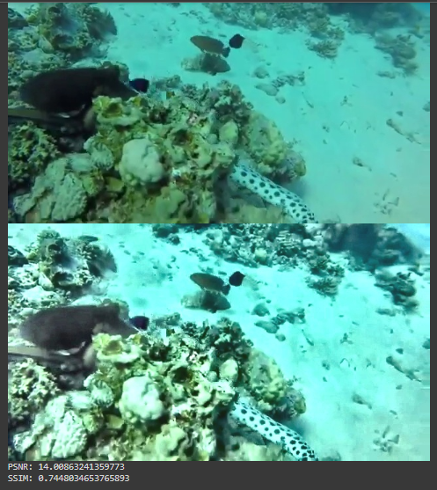

import cv2

def get_video_duration(video_path):

# Open the video file

video = cv2.VideoCapture(video_path)

# Get the total number of frames and frames per second (fps)

total_frames = int(video.get(cv2.CAP_PROP_FRAME_COUNT))

fps = int(video.get(cv2.CAP_PROP_FPS))

# Calculate the duration in seconds

duration_sec = total_frames / fps

# Convert duration to hours, minutes, and seconds

duration_hours = int(duration_sec // 3600)

duration_min = int((duration_sec % 3600) // 60)

duration_sec = int(duration_sec % 60)

# Close the video file

video.release()

return duration_hours, duration_min, duration_sec

# Path to the video file

video_path = "/content/Octopus1/Octopus1.mp4"

# Get the duration of the video

duration_hours, duration_min, duration_sec = get_video_duration(video_path)

# Print the duration

print(f"Video Duration: {duration_hours} hours, {duration_min} minutes, {duration_sec} seconds")



import cv2

from google.colab.patches import cv2_imshow

# Open the underwater video file

input_video = cv2.VideoCapture('/content/Octopus1/Octopus1.mp4')

# Get the video properties

frame_width = int(input_video.get(cv2.CAP_PROP_FRAME_WIDTH))

frame_height = int(input_video.get(cv2.CAP_PROP_FRAME_HEIGHT))

fps = int(input_video.get(cv2.CAP_PROP_FPS))

total_frames = int(input_video.get(cv2.CAP_PROP_FRAME_COUNT))

# Create a VideoWriter object to save the enhanced video

output_video = cv2.VideoWriter('enhanced_video.mp4',

cv2.VideoWriter_fourcc(*'mp4v'),

fps,

(frame_width, frame_height))

# Loop through each frame of the video

while input_video.isOpened():

ret, frame = input_video.read()

if not ret:

break

# Convert the frame to grayscale

gray_frame = cv2.cvtColor(frame, cv2.COLOR_BGR2GRAY)

# Apply histogram equalization to enhance the frame

equalized_frame = cv2.equalizeHist(gray_frame)

# Convert the equalized frame back to BGR (if you want to display it)

equalized_frame_bgr = cv2.cvtColor(equalized_frame, cv2.COLOR_GRAY2BGR)

# Write the enhanced frame to the output video

output_video.write(equalized_frame_bgr)

# Display the enhanced frame (optional)

cv2_imshow(equalized_frame_bgr)

if cv2.waitKey(1) & 0xFF == ord('q'):

break

# Release the input and output video objects

input_video.release()

output_video.release()

# Close all OpenCV windows

cv2.destroyAllWindows()

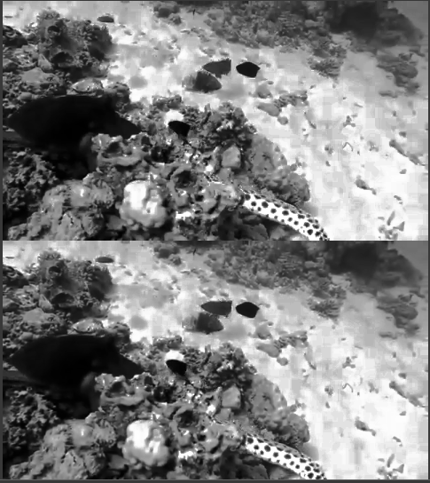

import os

import numpy as np

import matplotlib.pyplot as plt

from tensorflow.keras.layers import Input, Conv2D, MaxPooling2D, UpSampling2D

from tensorflow.keras.models import Model

from sklearn.model_selection import train_test_split

# Load and preprocess image data

def load_images(directory):

images = []

valid_extensions = ['.jpg', '.jpeg', '.png', '.bmp'] # Add more extensions if needed

for filename in os.listdir(directory):

filepath = os.path.join(directory, filename)

if os.path.isfile(filepath) and os.path.splitext(filename)[1].lower() in valid_extensions:

try:

img = Image.open(filepath)

img = img.resize((64, 64)) # Resize image to (64, 64)

img = img.convert('RGB') # Convert image to RGB (in case it's grayscale)

img = np.array(img)

images.append(img)

except Exception as e:

print(f"Error loading image file: {filepath}. Exception: {e}")

if not images:

print("No images found in the directory.")

return np.array(images)

# Load images from directory

image_directory = "/content/Octopus1/img"

images = load_images(image_directory)

# Normalize images

images = images.astype('float32') / 255.0

# Split data into training and validation sets

X_train, X_val = train_test_split(images, test_size=0.2, random_state=42)

# Define autoencoder model architecture

input_img = Input(shape=(64, 64, 3))

x = Conv2D(32, (3, 3), activation='relu', padding='same')(input_img)

x = MaxPooling2D((2, 2), padding='same')(x)

x = Conv2D(64, (3, 3), activation='relu', padding='same')(x)

encoded = MaxPooling2D((2, 2), padding='same')(x)

x = Conv2D(64, (3, 3), activation='relu', padding='same')(encoded)

x = UpSampling2D((2, 2))(x)

x = Conv2D(32, (3, 3), activation='relu', padding='same')(x)

x = UpSampling2D((2, 2))(x)

decoded = Conv2D(3, (3, 3), activation='sigmoid', padding='same')(x)

autoencoder = Model(input_img, decoded)

autoencoder.compile(optimizer='adam', loss='binary_crossentropy')

# Train the autoencoder

history = autoencoder.fit(X_train, X_train,

epochs=10,

batch_size=32,

shuffle=True,

validation_data=(X_val, X_val))

# Plot loss curves

plt.plot(history.history['loss'], label='Training Loss')

plt.plot(history.history['val_loss'], label='Validation Loss')

plt.xlabel('Epochs')

plt.ylabel('Loss')

plt.legend()

plt.show()

# Visualize original and reconstructed images

decoded_images = autoencoder.predict(X_val)

n = 10 # Number of images to display

plt.figure(figsize=(20, 4))

for i in range(n):

# Original images

ax = plt.subplot(2, n, i + 1)

plt.imshow(X_val[i])

plt.title('Original')

plt.axis('off')

# Reconstructed images

ax = plt.subplot(2, n, i + 1 + n)

plt.imshow(decoded_images[i])

plt.title('Reconstructed')

plt.axis('off')

plt.show()

